**Enhance a Model using Robotic Optimization Techniques**

Satyam Agrawal

Student CSE-Data Science 2nd year

Institute of Technology and Management, Gwalior-MP, India

Email: agarwalsatyam903@gmail.com

Dr. Jitendra Singh Kushwah

Associate Professor

Institute of Technology and Management, Gwalior-MP, India

Email: jitendra.singhkushwah@itmgoi.in

**Abstract**

The design and development of an Arduinobased robotic automobile with optical sensing and path following capabilities are shown in this work. This paper intends to meet the increasing need for self-governing robotic devices that can manoeuvre through ever changing situations. The robotic automobile combines motors, sensors, actuators, and Arduino micro controller boards to enable obstacle detection and autonomous navigation.

Infrared (IR) sensors are used by the route following algorithm to identify predetermined paths that are indicated on the surface by contrasting colors or lines. By continuously modifying its orientation in response to data from the sensors, the robotic car is able to follow the intended path thanks to the infrared sensors. The process of implementation entails integrating software algorithms created with the Arduino IDE with hardware components. PID (Proportional – integral – derivative) control is used by the path following algorithm to keep the vehicle aligned with the intended path while accounting for disruptions and detours.

The optical sensing system further improves the car's capacity to recognize barriers, locate landmarks, and manoeuvre through challenging situations. The microcontroller receives real-time data from the optical sensors, allowing the vehicle to make judgements and modify its course accordingly.

The testing findings show how well and consistently the Arduino-based robotic car can follow courses and navigate through different types of situations. The suggested approach has a great deal of promise for use in robotics, automation, education, and research, which will develop autonomous vehicle technology.

Keywords: Robotic, IR, Manoeuvre, Sensor, Vehicle.

**Introduction to Robotic Car: -**

Arduino robotic cars are amazing projects that combine programming, electronics, and mechanical engineering. These cars are meant to drive themselves through environments, taking present routes and making choices in response to input from sensors.  
  
Optical sensing and path following are essential parts of these robotic systems. They let the car see its surroundings, recognise obstacles, and maintain its course. We'll go over the fundamental ideas and parts needed to build an Arduino robotic car with optical sensing and path following in this introduction.

1. **Arduino Microcontroller:** The Arduino is the robotic car's brain. It is a microcontroller platform that manages sensor data, drives the motors, and carries out pre-programmed commands.
2. **Motors and Chassis:** The motors allow the robotic car to move, while the chassis serves as its structural foundation. Robotic cars usually drive themselves with DC motors attached to wheels.
3. **Motor Driver:** In order to regulate the motors' speed and direction, a motor driver circuit is required. It decodes signals from the Arduino and adjusts the motors' power supply accordingly.
4. **Sensors:**

* **Optical Sensors:** To identify lines or paths on the ground, optical sensors are utilized, such as infrared (IR) sensors or line-following sensors. In order to detect whether a line is present or absent, these sensors emit light and measure the intensity of reflected light.
* **Ultrasonic Sensors:** The robotic car uses ultrasonic sensors to detect obstacles and prevent collisions. They release ultrasonic waves, and by timing the waves' return bounce off of surrounding objects, they can determine how far away obstacles are.

1. **Programming:**  The Arduino IDE (Integrated Development Environment), which is built on C/C++, is used to programmed Arduino devices. The program outlines the robotic car's decision-making, environment navigation, and sensor input responses.
2. **Path Following Algorithm:** This algorithm controls the robotic car's behaviour when it follows a path or line. To keep the car on course, it usually entails reading sensor data, interpreting the line's position in relation to the car, and modifying the motor speeds.
3. **Control Logic:** To make decisions in real time, the control logic combines sensor inputs with the path following algorithm. For instance, the control logic might tell the vehicle to change direction or speed if it veers off the path.

**Component of Robotic Car: -**

You'll need a few different parts to build an Arduino robotic car that can sense light and follow a path. Here is a summary of the key components:

1. **Arduino Board:** Any suitable board will do, such as the Arduino Uno or Arduino Nano.
2. **Motor Driver:** In order to operate the car's motors, a motor driver is required. L298N and L293D are well-liked options.
3. **DC Motors:** In order to power the car's wheels, DC motors are required. The layout of your vehicle determines how many motors it has. A typical robotic car has two motors.
4. **Wheels and chassis:** The car's wheels and chassis give it its mobility and structure. A pre-made chassis is available for purchase, or you can build your own out of wood or acrylic.
5. **Sensors:**

* **Infrared (IR) Sensors:** IR sensors are employed in path or line following systems. For basic line following, two IR sensors are required at minimum. For this use, a popular infrared sensor module is TCRT5000.
* **Optical sensors:** These sensors can be used to identify environmental changes or obstacles. Useful modules include the QRD1114.

1. **Power Supply:** To power the motors and the Arduino board, you'll need a power supply. Typically, one will select a battery pack or a set of rechargeable batteries.
2. **Breadboard and Jumper Wires:** These are essential for prototyping and connecting components on the robotic car.
3. **Motor Wheels and Motor Mounts:** These are needed to attach the wheels to the motors securely.
4. **Circuit Components:** To interface sensors and other peripherals with the Arduino board, resistors, capacitors, and other electronic components may be required.
5. **Extra components:** You may require extra parts like LEDs, buzzers, Bluetooth modules, etc., depending on your unique design and features.

**Schematic Representation of Robotic Car: -**

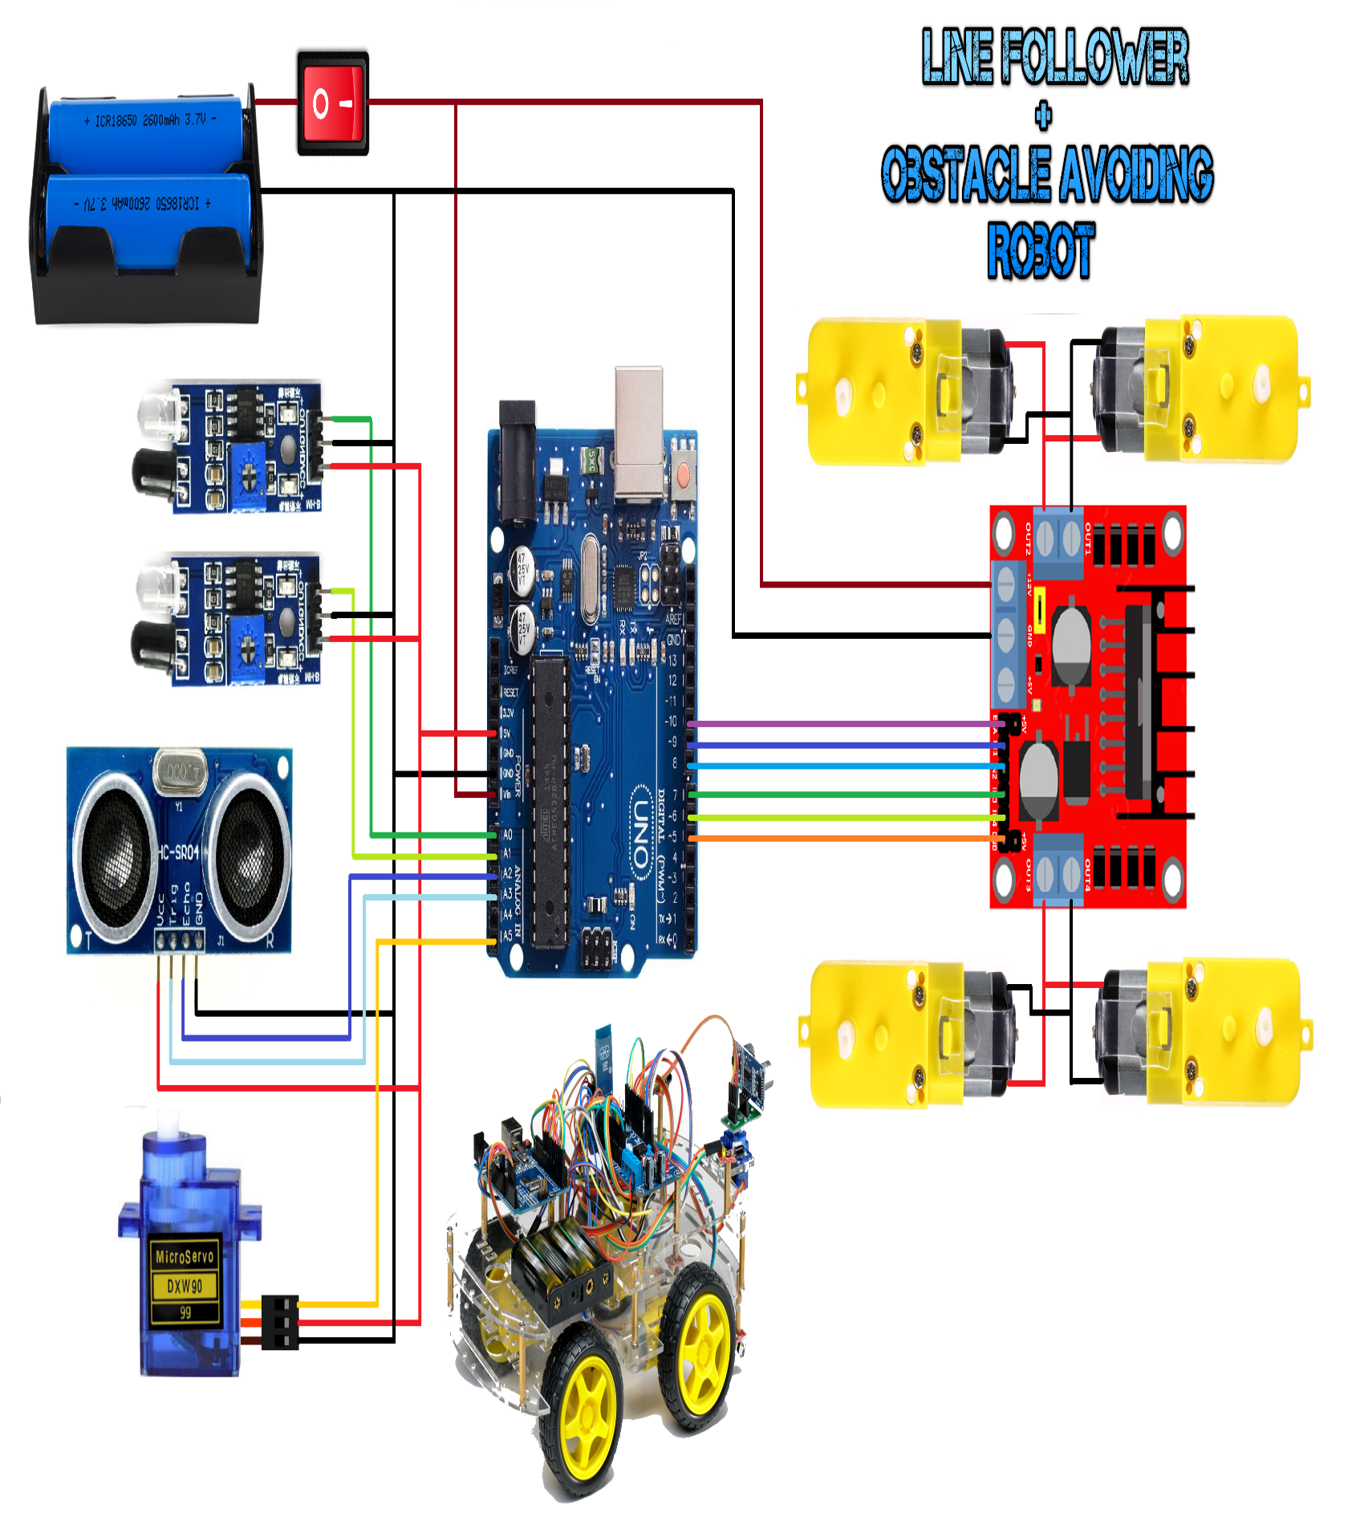

**Significance: -**

Arduino robotic cars equipped with path-following and optical sensing capabilities hold significant importance in various fields such as education, research, and practical applications. Here are some key aspects of their significance:

1. **Education**: Arduino robotic cars provide an excellent platform for students to learn about robotics, electronics, programming, and sensor technology in a hands-on manner. They offer a practical way for beginners to understand fundamental concepts such as control systems, sensor integration, and data processing.
2. **STEM Learning**: These robotic cars are particularly valuable in STEM (Science, Technology, Engineering, and Mathematics) education initiatives. They help students develop problem-solving skills, logical thinking, and creativity while engaging with real-world challenges in a fun and interactive way.
3. **Practical Application**: Arduino robotic cars with path-following and optical sensing capabilities have practical applications in various industries. They can be used for automated transportation within controlled environments such as warehouses, factories, and distribution centers. These robots can follow predefined paths, avoiding obstacles using optical sensors, and perform tasks such as inventory management or material handling.
4. **Research and Development**: Researchers and developers often use Arduino robotic cars as platforms for prototyping and testing new algorithms, control strategies, and sensor technologies. They serve as inexpensive and flexible tools for exploring concepts in robotics and automation before implementing them in more complex systems

.

1. **Problem Solving**: The integration of path-following and optical sensing allows the robotic car to navigate autonomously in dynamic environments. This capability is crucial for applications such as search and rescue missions, environmental monitoring, and agricultural automation, where robots need to adapt to changing conditions and navigate efficiently

.

1. **Innovation and Creativity**: Arduino robotic cars with path-following and optical sensing capabilities inspire innovation and creativity among hobbyists, makers, and DIY enthusiasts. They encourage individuals to experiment with different configurations, sensors, and software algorithms to enhance performance and explore new possibilities in robotics and automation.

**Future Scope: -**

The future scope of an Arduino robotic car equipped with path following and optical sensing capabilities is quite promising, with potential applications in various fields such as robotics, automation, education, and even in industries like logistics and agriculture. Here are some aspects of its future scope:

1**. Education and Learning:** Arduino robotic cars serve as excellent educational tools for students to learn about robotics, programming, and electronics. They provide hands-on experience in designing, building, and programming robots, making them ideal for STEM (Science, Technology, Engineering, and Mathematics) education initiatives.

2**. Research and Development:** Researchers and developers can explore the capabilities of Arduino robotic cars for advanced applications such as autonomous navigation, swarm robotics, and collaborative robotics. They can experiment with different sensors, algorithms, and control strategies to improve the performance and functionality of robotic systems.

3. **Automation and Industrial Applications:** Arduino robotic cars can be adapted for various automation tasks in industries, warehouses, and manufacturing facilities. With advanced path following and optical sensing capabilities, they can navigate through predefined paths, perform inspections, transport goods, and assist in various tasks, thereby enhancing efficiency and productivity.

4**. Smart Agriculture:** In agriculture, robotic cars equipped with optical sensors can be used for crop monitoring, weed detection, and precision farming. They can navigate through fields, collect data on crop health and growth, and help farmers make informed decisions about irrigation, fertilization, and pest control, leading to increased yields and reduced resource usage.

5. **Assistive Technology:** Arduino robotic cars can also find applications in assistive technology for people with disabilities or limited mobility. They can be designed to assist individuals in tasks such as fetching objects, navigating indoor environments, and providing remote monitoring and assistance, thereby improving independence and quality of life.

6. **Environmental Monitoring:** Robotic cars equipped with environmental sensors can be used for monitoring air and water quality, detecting pollution, and conducting environmental surveys in hard-to-reach or hazardous areas. They can collect data autonomously and transmit it to central systems for analysis and decision-making.

7. **Entertainment and Recreation:** Arduino robotic cars can be used for recreational purposes, such as hobbyist projects, robot competitions, and interactive exhibits. They can be programmed to perform various tasks, follow customized paths, and engage users in interactive experiences, making them popular among enthusiasts and hobbyists.

**Conclusion: -**

The Arduino robotic car with path following and optical sensing offers an innovative solution for navigation and obstacle avoidance in various environments. By combining Arduino microcontroller technology with optical sensors, the robotic car demonstrates the potential for autonomous movement and decision-making in real-world scenarios.

The inclusion of path-following capabilities enables the robotic car to navigate predefined routes accurately, making it suitable for tasks such as warehouse management, surveillance, or automated transportation. This functionality enhances efficiency and reduces the need for constant human intervention.

Moreover, the integration of optical sensing technology enables the robotic car to detect and respond to obstacles in its path effectively. This feature enhances safety and reliability, making the robotic car suitable for dynamic environments where obstacles may appear unexpectedly.

In conclusion, the Arduino robotic car with path following and optical sensing represents a significant advancement in robotics technology, offering versatility, efficiency, and reliability in various applications. Its development underscores the potential of Arduino-based systems in creating intelligent, adaptive, and autonomous robotic platforms. As technology continues to evolve, further enhancements and refinements to such systems are expected, opening up new possibilities for automation and robotics in diverse fields.

**Reference: -**

* <https://www.arduino.cc/>
* <https://quartzcomponents.com/blogs/electronics-projects/line-follower-robot-using-arduino/>
* <https://projecthub.arduino.cc/lightthedreams/line-following-robot-34b1d3>
* <https://projecthub.arduino.cc/parth2008/obstacle-avoiding-car-d7450d>
* <https://www.youtube.com/watch?v=4PQgjjOqJa4&t=2s>
* <https://marobotic.com/2023/10/22/line-follower-obstacle-avoiding-robot-using-arduino-and-l298-motor-driver/>